# Lab 1: HTML Basics

Goal of this lab : Understand and practice basic HTML tags.

You will create your own web page by choosing a specific topic. You can use Wikipedia for example to get data about your chosen topic (talk about a technology, a city, a historical event, etc.).

Your web page must include the following elements:

* a title
* at least two level headings
* at least one paragraph
* at least one list (ordered or unordered) with at least three list items
* at least one hyperlink to another web page
* at least one image
* at least one horizontal rule
* at least one kind of normal text formatting (bold, italic or underline)

The example web page will look like this, but we will add one feature at a time and check the result in a web browser after each step.

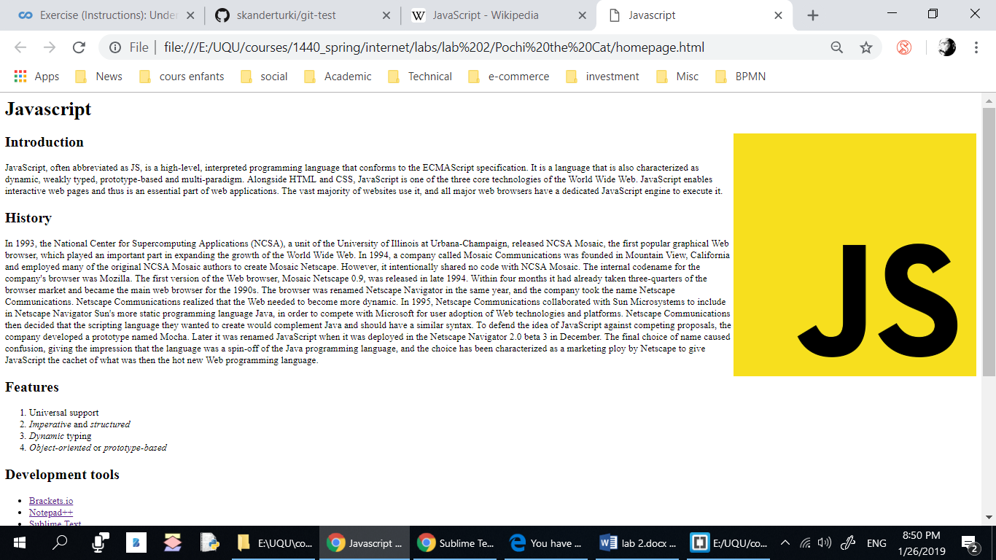

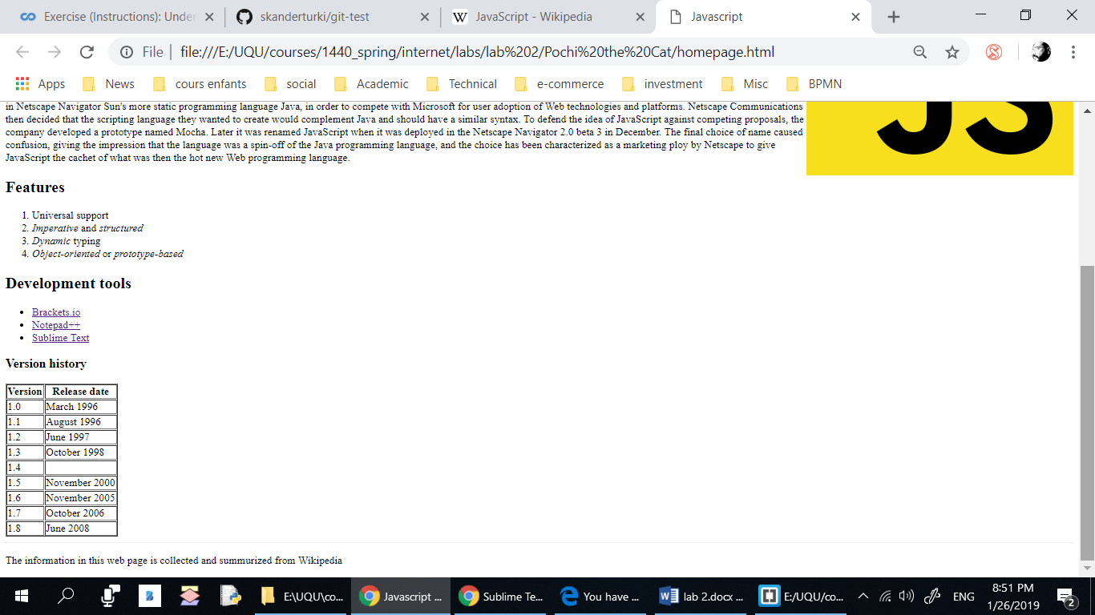

## Development Tool:

Use Visual Studio Code + Google chrome.

## Steps:

1. Create a folder on your Desktop named lab_1.
2. *Start your editor (VSCode).*
3. Create an empty file called index.html.
4. Add the DOCTYPE tag.
5. Start by creating the root **html** tag.
6. Add a **head** section and a **body** section. Add a **title** section.
7. Save your file and check if it is working by opening it in a browser.
8. Add a heading h1 for the page.
9. Add one or more paragraphs of text among the subheadings, making sure to put each of your paragraph in **p** tags.
10. Add a list under a subheading.
11. Add hyperlinks to the external website where you got the data (Wikipedia page?)..
12. Add a footer section using the **Footer** tag for a horizontal rule line to separate the author and date from the rest of the page.
13. Find an image on the web and save it to the folder where your web page is saved. Then include the image to your document using the img tag. Image files vary widely in size, so you might find that your image is too large on the page when viewed in a browser. In this case, you can modify the **width** attribute. Try resizing the browser window and watch the image carefully.
14. Add an **alignment** attribute to your **img** tag. Adding **align=right** to the example above puts the image on the right side of the window, allowing text to appear to its left.
15. Add a table. Add an "border" attribute inside the brackets to make the border visible. Add all the necessary tags (th, td) inside the table to organize the content.